Now we are going to move ahead and drag and drop our first asset into the scene.
Now we will add ground tile to the screen by dragging and dropping it to the Heirarchy panel from the Project panel or similarly you can drag and drop it to Scene panel
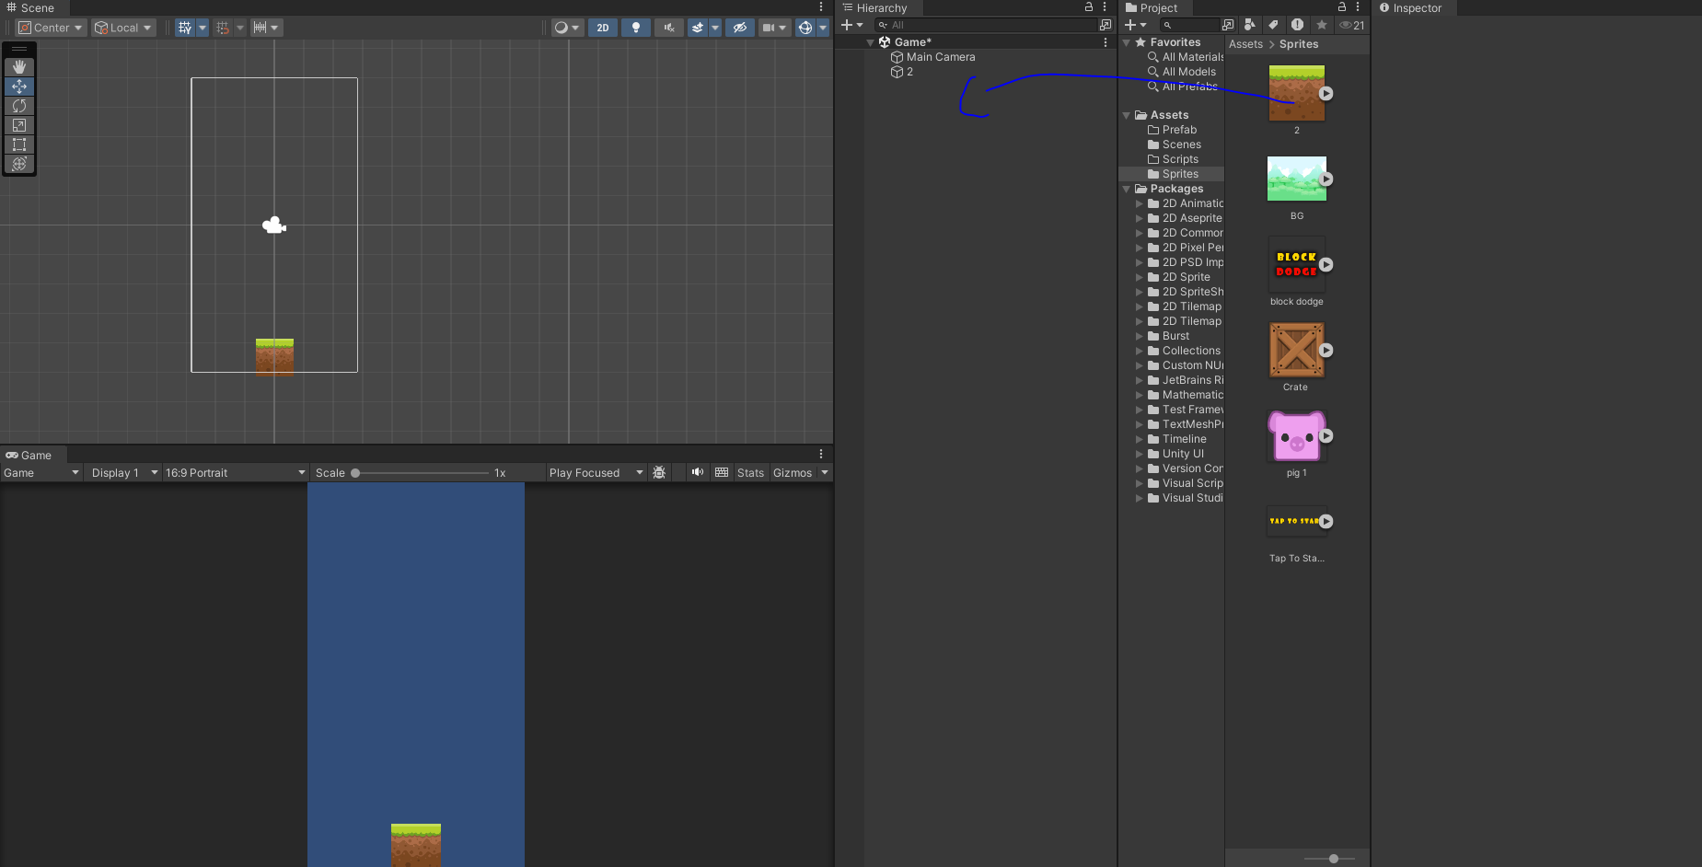
you van see the mention of the sprite insides the Heirarchy panel as 2
you can use move tool to move anything present inside the scene panel
by choosing the marked utton below from the toolbar
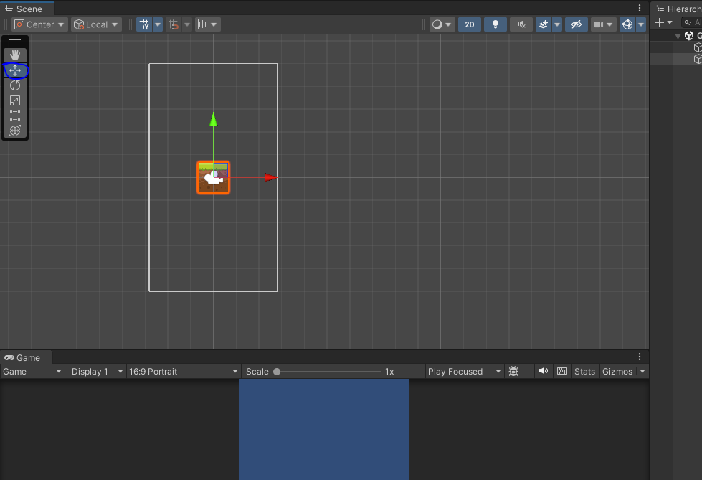
your object will be surrounded with movement ticks through them you can move the object in any direction by dragging the above respected sticks.
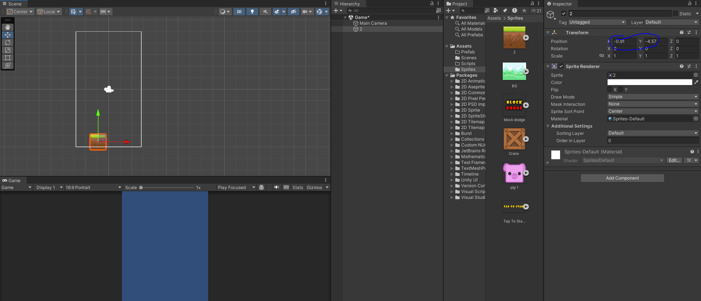
I think the unity take the center of the screen as origin
do we will make the x value as 0 so it will come in the center
Now we will rename the 2 as generally we do into Ground.
Inspecter panel shows the properties and different component related to that object or file
So we select the asset Ground and then in Inspector go to Draw mode and then choose Tiled
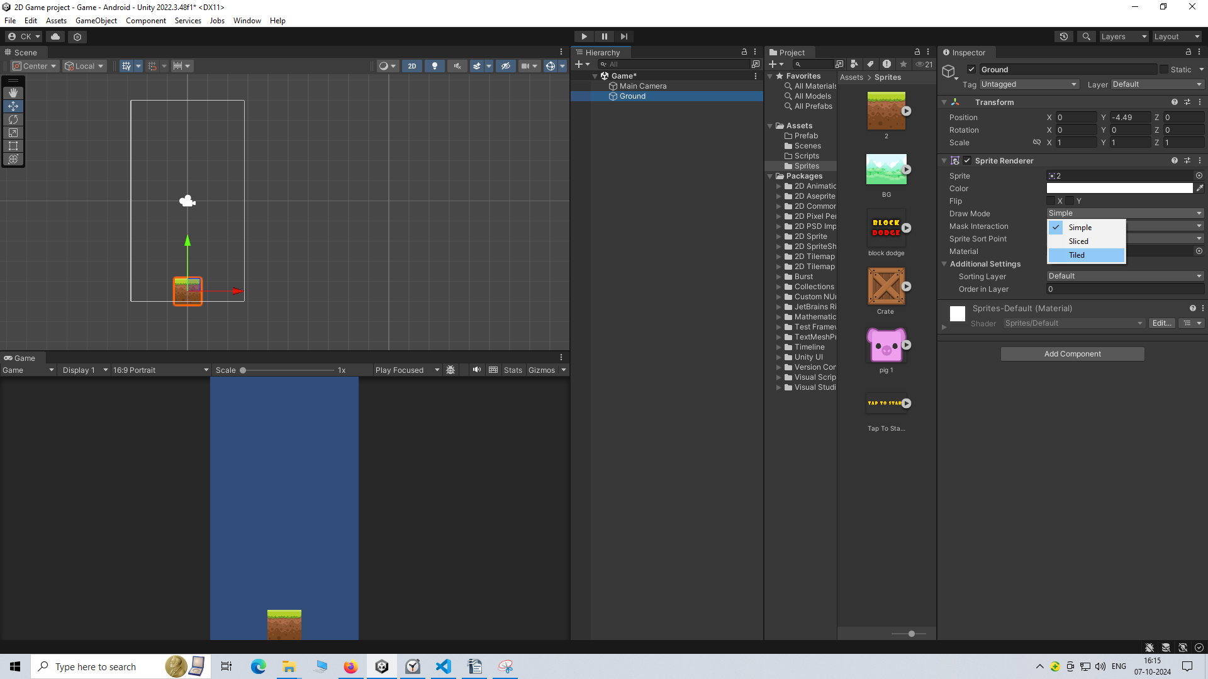
This will make the object image repeatable when you scale in any way(and it take the reference of the current image inside the object) but if you keep it simple then the image inside may get stretched and may not look good
To do moving and simulataneously you can use rectangle tool inside the toolbar as marked below
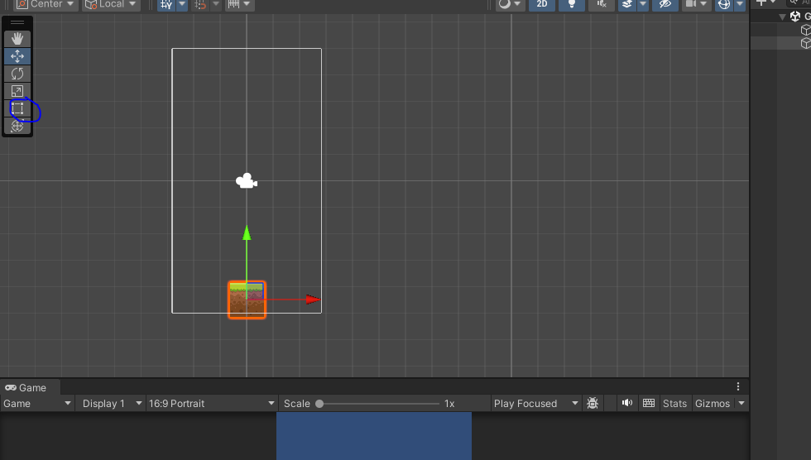
If you drag any object with it and if it from the corner it will be scaled or will be moved if you move it from the center.
Now our ground is ready now we are going to drag and drop our player onto the screen
So we are going to drag and drop it in our scene or heireachy panel q
To scale something in equal ratio you can hold shift and then drag it then it will be scaled uniformly
Now to set an object showing on screen as in order like a stack or you want an asset to look above any asset then you can go to its properties in inspector panel and then go to Additional Settings and then expand it and you can go to Order in Layer
So we want that the pig should look above the ground so we set the set in order more than ground
Now we will rename the pig as player
Now we will add some component to player
Note:-
I think the component acts as a feature added to the asset by adding that to the assets and then the asset behave in certain way due to a particular added component (I think it saves a lot of time in coding)
So now we will add component to the player by selecting it and then go to inspector panel and then go to add component button
and then a submenu will be opened and then go to Physics 2D
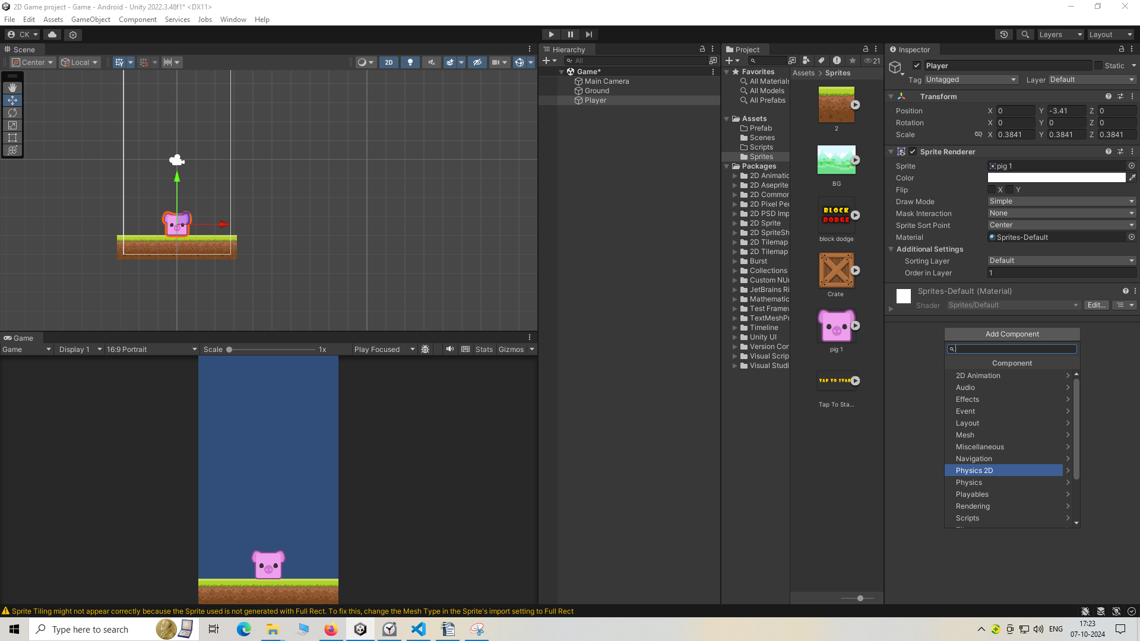
and then to Rigidbody 2D
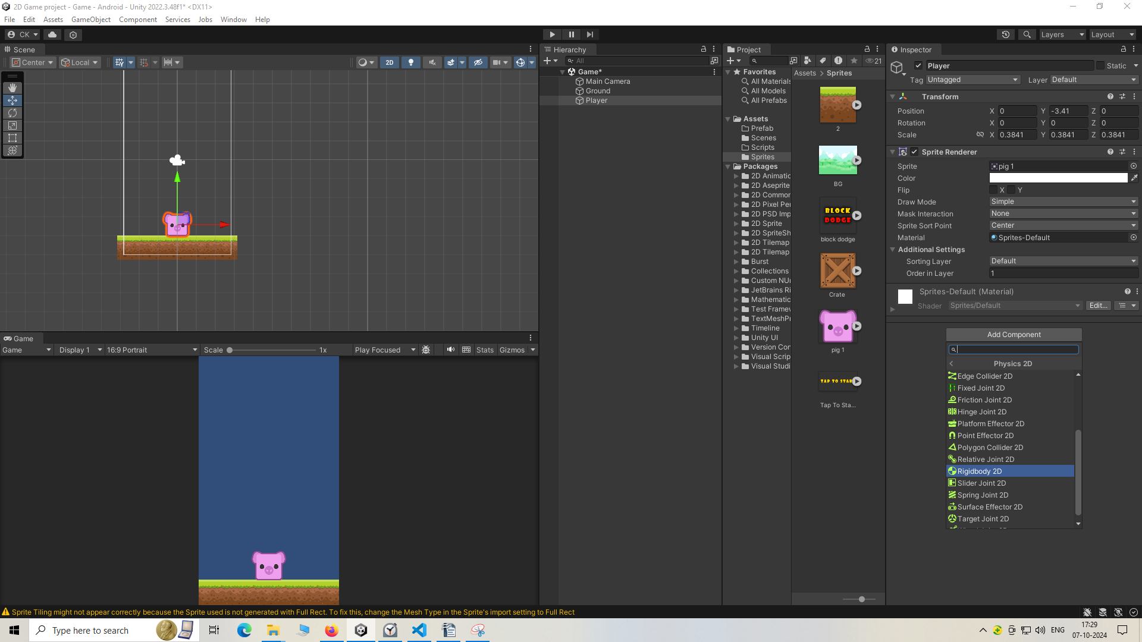
and now you can see Rigidbody 2D component box inside the inspector
So now it(player) will be able to interact with the physics engine of Unity(maybe engine dealing with the physics of our game).
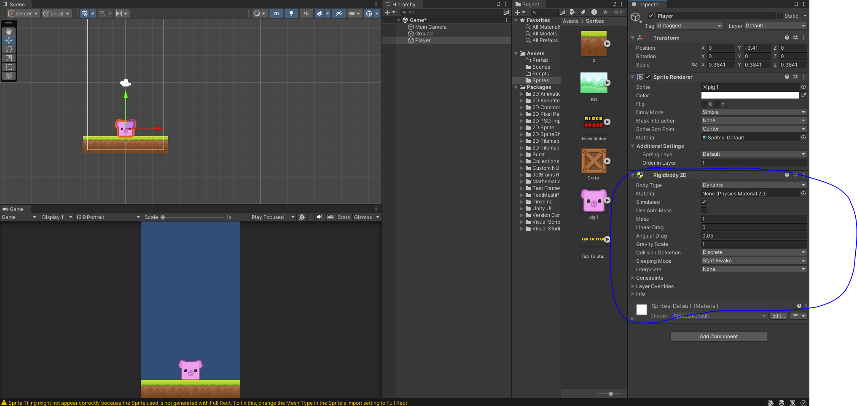
Now select the player and then inside the Rigidbody 2d component make the Gravity scale 0 and angular drag to 0 so that it does not get fall down when the game run(or preview)
Gravity scale:-

Gravity scale tell property of where the graity will work whether in upward direction or downward direction
For downward direction give positive number and for upward direction give negative number

Angular drag

In Unity, the Angular Drag property of a Rigidbody 2D component affects the rotational motion of the object. Specifically, it determines how quickly the object's rotation slows down when no torque is applied.
Here's how it works:
- Higher Angular Drag: The object will lose its rotational speed more quickly. This means that if you stop applying torque, the object will come to a halt faster.
- Lower Angular Drag: The object will retain its rotational speed for a longer time, making it spin more freely.
This property is useful for controlling the rotational dynamics of 2D objects in your game, allowing you to create more realistic or desired movement behaviors. For example, you might want a heavy object to stop rotating quickly when a force is no longer applied, while a lighter object could spin more freely.
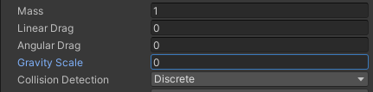
Now go to constraint properties and then expand Constraint
to go to Freeze Rotation and check z to freeze rotation in z axis and then go to Freeze Position. And then check y
Through this we are actually freeing the movement of our player in y direction
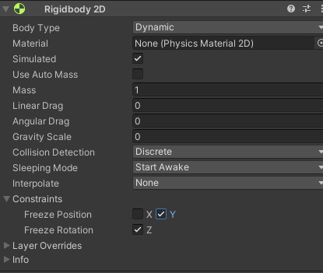
Now we will add another component called BoxCollidor2d
We can add ot by going to add component
and then a submenu will be opened there go to Physics2D and then the submenu will be updated
in that submenu go to Boxcollidor2D
Because we want it to collide with other object
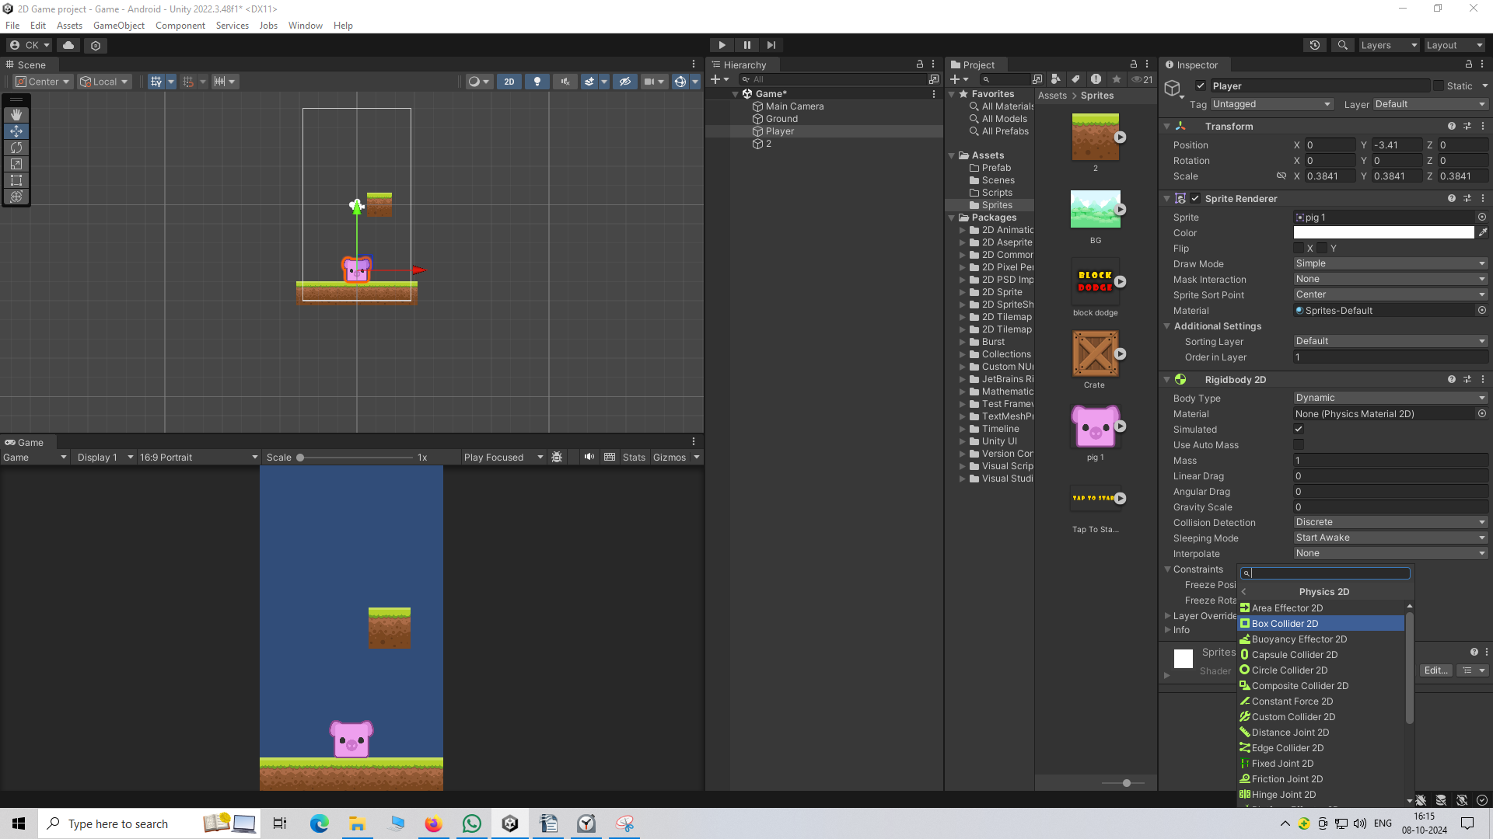
Note:-
You can move around the scene panel by holding the scroll click and then drag
Now if you zoom into our player in Scene panel
then you may see when you select the player that the player enclosed inside a green colored box
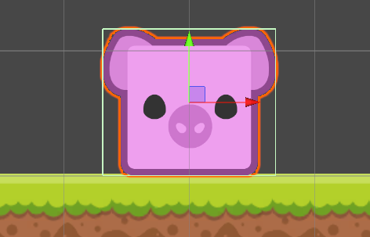
This is the box collider so it will react when it coincide with other assets(maybe sprites) box collidor
If you want to change the height or width of these collidor just go to box collidor component in Inspector panel
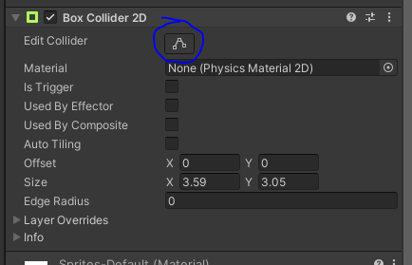
and then go to edit collidor button as marked above
then you can scale the collidor box
by stretching the collidor box along the edges
you can change the background color of the game screen as shown in the Game panel
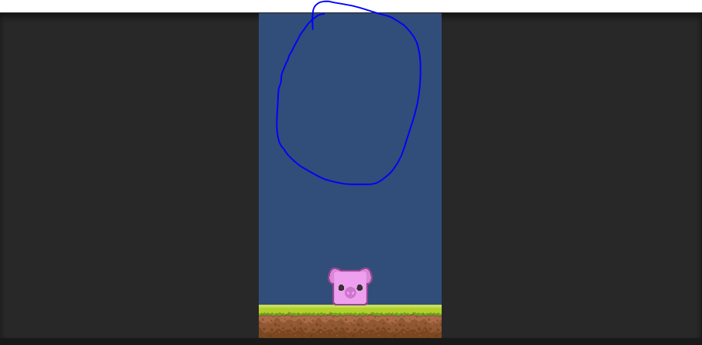
by selecting the camera in the Scene Panel and then go to inspector panel
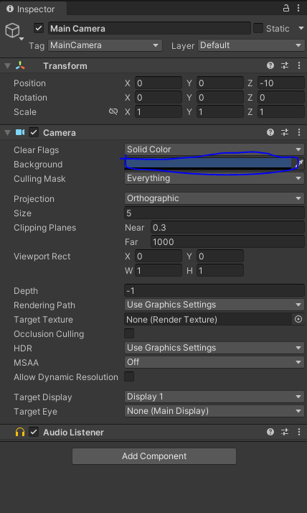
and then go to Camera section and then click on background and then a color mini temporary window like below
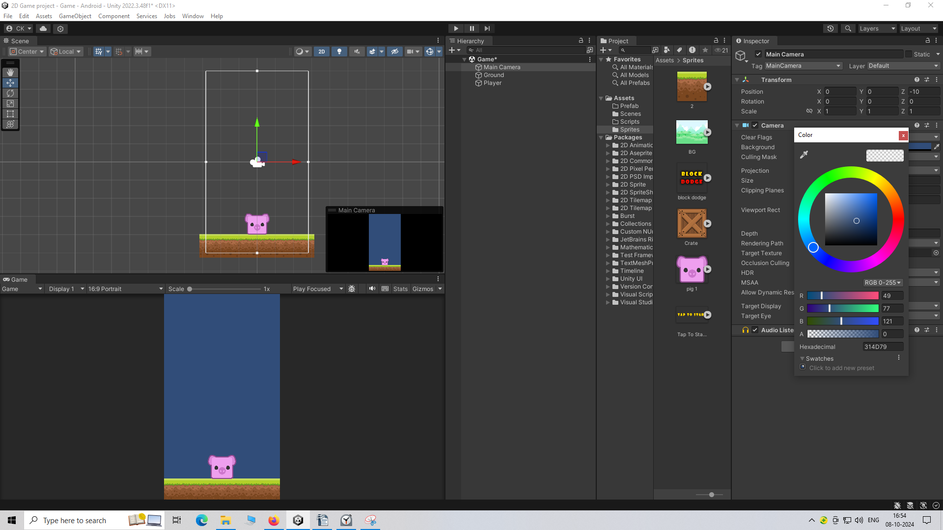
Now choose some lightish bluer color for our background
R 146
G 236
B 255
A 0
Hexadecimal code=92ECFF
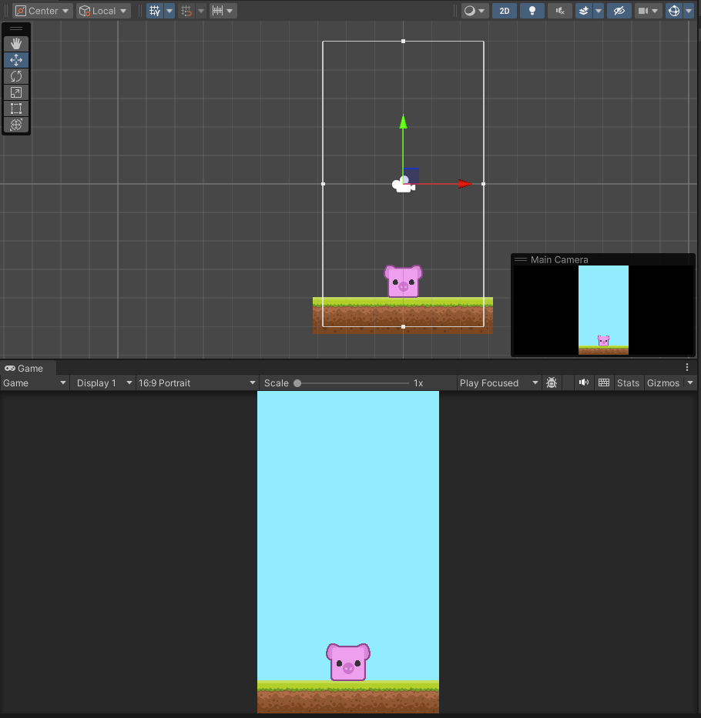
Now you can see our background color is now changed to light blue color.

